**Mini Project Report**

HOTEL MANAGEMENT SYSTEM



SUBMITTED TO

**SAVITRIBAI PHULE PUNE UNIVERSITY, PUNE**

**FOR THE DEGREE OF**

MASTER OF COMPUTER APPLICATION

**SUBMITTED BY**

**Shaileja Padmakarrao Manjarmkar**

**Sitala Shivpoojan Vishwakarma**

**Tejas Chandrakant Pawar**

**Hrithik Anil Mnadale**

ACADEMIC YEAR 2021-2022

UNDER THE GUIDANCE OF

**Prof. Harini Pawar**

Dr. D. Y. Patil Educational Federation

Near Talegaon Railway Station, Varale,

Talegaon , Pune- 410507

**CERTIFICATE**

This is to certify that the project titled “PROJECT NAME” has been done by STUDENT NAME student of YEARFIELD as per the project requirement for SEMESTER for the academic year YEAR under the guidance of PROFESSOR NAME

COLLEGE NAME

UNIVERSITY NAME

Signature of ProjectGuide:

Date:

SignatureofExaminer Signature of DepartmentHead

Date: Date:

**INDEX**

|  |  |  |
| --- | --- | --- |
| 1. | Introduction | 4 |
|  | Objective | 5 |
|  | Feature | 5 |
| 2. | Analysis | 6 |
|  | History of Hotel Management System | 6 |
|  | Cost Benefit Analysis | 7 |
|  | Contribution of Hotel Management System | 8 |
|  | Advantages of Hotel Management System | 9 |
|  | Drawbacks in existing software | 9 |
|  | Requirement Specifications | 10 |
|  | Hardware Requirements | 11 |
| 3. | Module Description | 12 |
|  | Admin Module | 12 |
|  | Product Module | 12 |
|  | Customer Module | 12 |
| 4. | Proposed System | 16 |
| 5. | Analysis & Design | 24 |
|  | Class Diagram | 24 |
|  | ER Diagram | 25 |
|  | Flowchart | 26 |
|  | Global Use Case | 27 |
|  | Activity Diagrams | 28 |
|  | Sequence Diagrams | 37 |
|  | Screenshots | 46 |
| 6. | Database Tables | 56 |
|  | Customer Table | 56 |
|  | Room Table | 56 |
|  | Employee Table | 57 |
|  | Driver Table | 57 |
|  | Login Table | 57 |
|  | Department Table | 57 |
| 7. | Testing Phase | 60 |
|  | Unit Testing | 60 |
|  | Integration Testing | 60 |
|  | System Testing | 60 |
|  | Acceptance Testing | 60 |
| 7. | Future Scope | 61 |
| 8. | Conclusion | 62 |

# **INTRODUCTION**

### In my project “**Hotel Management System**” I have tried to show how the data/information in hotels is managed. This is just an overview of management in hotels. It manages and maintains the records of customers, rooms, employees and drivers in the hotel. The project is aimed to maintain the day-to-day state of admission/vacation of Residents, List of employees, room details etc. Main objective of this project is to provide a solution for hotels to manage most their work using computerized processes.

This software application will help admin to handle customer information, room allocation details, Payment details etc.

The rooms have different categories like single bed, double bed etc. so their charges and records will be maintained accordingly.

This software has been made in a user friendly interface, so that anyone can add, delete, update the entries and handle all the transactions easily. As a security I have provided Admin username and Password.

The project, Hotel Management System is a desktop-based application that allows the hotel manager to handle all hotel activities online. Interactive GUI and the ability to manage various rooms, employees, drivers and customers make this system very flexible and convenient. This application gives managers the power and flexibility to manage the entire system from a single online system. Hotel management project provides room booking, staff management and other necessary hotel management features. The system allows the manager to post available rooms in the system.

**OBJECTIVE**

### The objective of the Hotel Management System is to develop a project which maintains booking of rooms, providing drivers, etc. It is a windows based application to be implemented in Java

The Purpose of the whole process is to ease the daily or regular activities of the Hotel Management into an automatic computerized retrievable process. The daily activities includes the Room activities, Entering details of the new customer check in, To allocate a room as per the customer need and interest, Recording the checkout time and details, Releasing or Empty of room and to record the process in a computer system for future.

Main objective of this project is to provide a solution for hotels to manage most their work using computerized processes. This software application will help admin to handle customer information, room allocation details, Payment details etc.

* Keeping records of admission of for customers.
* Facilities provided by hotels are fully utilized in an effective and efficient manner.

**FEATURE**

1. Hotel Room Bookings and Reservation
2. Front Desk Operations
3. Managing Guest Profile
4. User Privilege and security control
5. Keeping a tab on guest check-in check-out status
6. Maintenance of hotel rooms.
7. Providing a user friendly Interface.

1. **ANALYSIS**

Study Of Current System-

Current System of Hotel Management is fully based on paperwork. Hotel Management has to manage all records of customers and rooms on paper.

Problem and Weakness Of Current System-

Paper work is a tedious job. There can be delay and the problem of human error in al l locating rooms and providing resources.

# **HISTORY OF HOTEL MANAGEMENT SYSTEM**

Hotel Management Systems are able to automate the process of hotels. It is useful for authorities which keep track of all the users registered. The authority can hotel packages room detail and availability of rooms, online booking and other packages. The following steps that give detailed information of the need for electronic managements are

Performance

During the past several decades, the records are supposed to be manually handled for all activities. The manual handling of records is time consuming and highly prone to error. To improve the performance of the hotel management system, the computerized system had to be undertaken.

Efficiency

The basic need of this application is efficiency. The website should be efficient so that whatever the user submits any detail the application is update idimmediate and automatically. These records will be useful for other instantly.

Control

The complete control of the electronic system is under the hands of authorized persons who have the password to access the system and illegal access is not permitted. Control is entirely in the hands of the administrator and the other members have the right to see the records not to change any transaction entry.

Security

Security is the main criteria for electronic hotel management systems. Since illegal access may corrupt the database and ensure protection of the stored data.

## Cost Beneﬁt Analysis

* Role Based Screen Access
* The roles can be any of the following:
* *Administrator Role*- is for provisioning of Register/Update/Remove/ Transfer Contract.
* *Data Entry role*– for entering of basic form data
* *Supervisory role*– for review/approval/rejection/modification of data
* *Decision making role*– viewing of report and decision making

**Contribution**

Hotel Management Software is programmed to enable HR professionals for managing the data and information of the company’s employees on a regular basis. The easy information regarding the employees is including contact details, investment details, and much more.

**Accuracy:**

Your system must be able to accommodate your employees and various customers or guests at your hotel. Once a good system is in place, you will have an accurate record of the check-in and check-out status of a customer. An automated system minimizes the possibility of human error, as the only real factor is whether employees remember to clock in and out.

**Record-Keeping:**

Another feature of a hotel management system is that it can be used to keep detailed and accurate records. These records can be stored in a main database on site, online or in an outside record-keeping facility.

Record-keeping can help you monitor trends such as how much overtime you're paying and how many employees participate in your company retirement plans

# **ADVANTAGES OF HOTEL MANAGEMENT SYSTEM**

* Sometime it happens that the rooms get booked soon when one visits the place therefore user can make advance booking using this system.
* It saves user time in searching a room.
* The system is useful as it calculates an exact cost of rooms for requested number of days.
* It saves organization resources and expenses.
* This system is effective and saves time and cost of users.
* It is less time consuming and provides maximum accuracy.

# **DRAWBACKS OF HOTEL MANAGEMENT SYSTEM**

* The booking process usually requires a customer identity, which the system cannot detect.
* It requires a reliable internet connection

## REQUIREMENT SPECIFICATION

User Requirements

There should be software which allocates rooms automatically and maintains records of customers.

System Requirements

There should be a database backup of the hotel management system. There should be a Java supported framework for the system. Operating system should be WindowsXP or a higher version of windows.

User Interface

The User interface required to be developed for the system should be user friendly and attractive.

There are two sets of java APIs for graphics programming:

AWT (Abstract Windowing Toolkit) and Swing.

* AWT API was introduced in JDK 1.0. Most of the AWT components have become obsolete and should be replaced by newer Swing components.
* Swing API, a much more comprehensive set of graphics libraries that enhances the AWT, was introduced as part of Java Foundation Classes (JFC) after the release of JDK 1.1. JFC consists of Swing, Java2D, Accessibility, Internationalization, and Pluggable Look-and-Feel Support APIs. JFC was an add-on to JDK 1.1 but has been integrated into core Java since JDK1.2.

For the development of this project both hardware and software were required. The hard required is any machine compatible for running the softwares and resources required.

Software Requirements

* + Operating System Windows10
  + Front End Java, EclipseIDE
  + Back End MySQL 8.0 CMD Line

**Hardware Requirements**

* + Desktop PC or a Laptop
  + Printer
  + Operating System – Windows10
  + Intel® Core TM i3-6006U CPU @2.00GHz
  + 4.00 GBRAM
  + 64-bit operating system, x64 based processor
  + 1024 x 768 monitor resolution
  + Keyboard and Mouse

1. Module Description:

After careful analysis the system has been identified to have the following modules:

1. **Admin Module:**

Admin module in this system will make sure that the user that is acting as an admin of the system can cooperate and easier to manage. This admin module also will make grocer who is using this system can easily manage their product such as adding product, edit the product price, create new category and sub-category, viewing customers order and also can keep track with business flow. There are two system management that admin will control. First, the product management system and second, purchase management system. For the product management system, admin can edit all the product details and also can add a new category and add new product. For the purchase, management system, admin can view all the purchasing process that is made by the customers.

1. **Product Module:**

This module includes product information like product id, name, category, sub-category, etc….Here we can add, edit and delete the product details.

**3. Customer Module:**

Here we can add, update and delete the information of customer which includes customer name, mobile no. and address.

**Detailed Description of Technology Used*:***

* JAVA
* SQL : Structured Query Language
* UML : Unified Modeling Language

**SQL: -**

MySQL is a relational database management system based on SQL – Structured Query Language. The application is used for a wide range of purposes, including data warehousing, e-commerce, and logging applications. The most common use for MySQL however, is for the purpose of a web database.

MySQL is a component of the [LAMP](https://en.wikipedia.org/wiki/LAMP_(software_bundle)) [web application](https://en.wikipedia.org/wiki/Web_application) [software stack](https://en.wikipedia.org/wiki/Software_stack) (and [others](https://en.wikipedia.org/wiki/List_of_AMP_packages)), which is an acronym for [Linux](https://en.wikipedia.org/wiki/Linux), [Apache](https://en.wikipedia.org/wiki/Apache_HTTP_Server), MySQL, [Perl](https://en.wikipedia.org/wiki/Perl)/[PHP](https://en.wikipedia.org/wiki/PHP)/[Python](https://en.wikipedia.org/wiki/Python_(programming_language)).

MySQL is used by many database driven web applications,

including [Drupal](https://en.wikipedia.org/wiki/Drupal), [Joomla](https://en.wikipedia.org/wiki/Joomla), and [WordPress](https://en.wikipedia.org/wiki/WordPress). MySQL is also used by many

popular [websites](https://en.wikipedia.org/wiki/Website), including [Facebook](https://en.wikipedia.org/wiki/Facebook), [Flickr](https://en.wikipedia.org/wiki/Flickr), [Media-Wiki](https://en.wikipedia.org/wiki/MediaWiki), [Twitter](https://en.wikipedia.org/wiki/Twitter), and [YouTube](https://en.wikipedia.org/wiki/YouTube).

Structure Query Language (SQL) is a database query language used for storing and managing data in Relational DBMS. SQL was the first commercial language introduced for E.F Codd's Relational model of database.

Today almost all RDBMS (MySQL, Oracle, Informix, Sybase, and MS Access) use SQL as the standard database query language. SQL is used to perform all types of data operations in RDBMS.SQL is the standard language for Relational Database System. All the Relational Database Management Systems (RDMS) like MySQL, MS Access, Oracle, Sybase, Informix, Also, they are using different databases, suchas:

* MS SQL Server using T-SQL,
* Oracle using PL/SQL,
* MS Access version of SQL is called JET SQL (native format)etc.

**UML:-**

UML (Unified Modeling Language) is a standard language for specifying, visualizing, constructing, and documenting the artifacts of software systems. UML was created by the Object Management Group (OMG) and UML 1.0 specification draft was proposed to the OMG in January 1997. It was initially started to capture the behavior of complex software and non-software system and now it has become an OMG standard. This tutorial gives a complete understanding on UML.

OMG is continuously making efforts to create a truly industry standard.

* UML stands for Unified Modeling Language.
* UML is different from the other common programming languages such as C++, Java, COBOL, etc.
* UML is a pictorial language used to make software blueprints.

 

*    UML can be described as a general purpose visual modeling language to visualize, specify, construct, and document software system.
* Although UML is generally used to model software systems, it is not limited within this boundary. It is also used to model non-software systems as well.

For example, the process flows in a manufacturing unit, etc.UML is not a programming language but tools can be used to generate code in various languages using UML diagrams. UML has a direct relation with object oriented analysis and design. After some standardization, UML has become an OMG standard.

     

**CHAPTER 2 : PROPOSED SYSTEM**

### 4. **Proposed System**

The system incorporates all the requirements suggested by the user. It is designed in such a way that it can hold all the information that is needed for data storage, data processing and to generate various report as per the user requirements.

The proposed system will have the following features:

* + - It is computerized.
    - The computer can hold amount of data in its storage device.
    - The operation and the speed is much more high as compared to current system.
    - We can easily print any of the reports which we are in need.
    - Huge amount of data can be stored in the computerized database system.
    - It is User-friendly and easy to use.
* **Time saving:-**

The existing working of the purchase and sales is manual and it takes a lot of times. Thus now by computerizing the system it will consume less time as the data entry in multiple register in the manual system.

* **Less Paper Work:-**

In the manual system there were many form and registers maintained which will get reduced.

* **Reduction in data redundancy:-**

In the manual system there were register maintained in which there was a lot of repetition which will get avoided.

**Objectives of Proposed System:**

Following are the main objectives of the System:-

* + To design a proper computerized system to keep track of all information about the purchase and sales of company.
  + Eliminate the use of manual work to maintain the information related to rejection.
  + To generate accurate & precise reports. This will aid in decision making.
  + To provide more secure environment to the present system.
  + Human errors are reduced
  + Makes system user friendly
  + Data Storage and Retrieved id done efficiently in system

**User Requirements:**

The user requirements are the key task to be concentrated during the system life cycle

* User needs to registration.
* Users have to select product to buy it.
* Database shows the information of every user.

**User characteristics**

The user class who will be using this system is the users, with the anticipation of the usage of the system: user is having the technical and implementation knowledge. As he is the person who is actually bringing life to the system, hence it is not so important that the flow of the system will be unknown to them, in other words, these users must know all the processes, so whenever sought for these users must be able to track the changes to be made and the affected changes that are made to the system.

**Non Functional Requirements:**

* The performance of the system should be fast and accurate.
* The system should be user friendly.
* System will use secured database.
* System will have two types of users and those are access constraints.
* Proper user authentication should be provided.
* User will search, update, delete and save records.

**CHAPTER 3 : ANALYSIS & DESIGN**

**Problem Definition:**

Its ***purpose*** is to check the validity of the algorithm by identifying logic errors early.

If the requirements and the parameters of the **problem** are clearly understood then the actual output of the development program (process) is far more likely to meet the expected output.

* **Requirement Specification**

A software requirements specification (SRS) is a detailed description of a software system to be developed with its functional and non-

functional requirements. The SRS is developed based the agreement between customer and contractors. It may include the use cases of how user is going to interact with software system

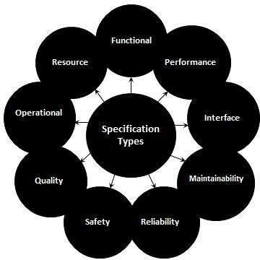

* **Planning andScheduling**

Planning involves identification of a task or tasks that need to

occur. Scheduling involves assigning the future action needed to accomplish a given task to occur on a certain date and time

**SYSTEM DESIGN**

* **Data Design:**

Data design is the first design activity, which results in less complex, modular and efficient program structure. The information domain model developed during analysis phase is transformed into data structures needed for implementing the software. The data objects, attributes, and relationships depicted in entity relationship diagrams and the information stored in data dictionary provide a base for data design activity. During the data design process, data types are specified along with the integrity rules required for the data.

* **Physical Design**

Physical design relates to the actual input and output processes of the system. It focuses on how data is entered into a system, verified, processed, and displayed as output. It produces the working system by defining the design specification that specifies exactly what the candidate system does.

* **Design Methodology**

Software design methodology provides a logical and systematic means of proceeding with the design process as well as a set of guidelines for decision- making. The design methodology provides a sequence of activities, and often uses a set of notations or diagrams.

* **Design Overview**

Software design is the process of envisioning and defining software solutions to one or more sets of problems. One of the main components of software design is the software requirements analysis (SRA). SRA is a part of the software development process that lists specifications used in software engineering**.**

**Coding Details and Code Efficiency:**

The code of the system is written in the .net with C# by using visual studio.

**Feasibility Study:**

The purpose of feasibility study is to investigate deeply the recommended system. Feasibility study is carried out to describe and evaluate the proposed system. The study Will justify whether the project is feasible or not and whether it is worthwhile or not. Therefore, a feasibility study of the proposed system needs to be carried out in Order to:-

* + Provide a better understanding of the System.
  + Clarify objectives in the proposed System.
  + Assess and recommend what course of action should be taken for the Solution proposed
  + Describe the outputs.

There are many factors to assess when analyzing whether the proposed system is Feasible and should be adopted. These factors are Technical Feasibility, Operational Feasibility, Social Feasibility and Economical Feasibility**.** In order to Test Technical, Operational and Economical Feasibility, The system Comparisons are carried out between The Proposed System and The Existing System, so that the proposed system can be easily taken over.

1. **Technical Feasibility:**

**Technical Feasibility** is defines as the **feasibility** that is concerned with specifying equipment and software that will successfully satisfy the user requirement. It compasses the **technical** needs of the system. It helps organizations determine whether the **technical** resources meet capacity and whether the **technical** team is capable of converting the ideas into working systems. **Technical feasibility** also involve the evaluation of the hardware, **software**, and other **technical** requirements of the proposed system.

The Technical feasibility deals with some facts such as:-

* + Is the proposed system technically feasible?
  + Is it within the state of art?
  + What hardware and software will be required?

1. **Operational Feasibility:**

Operational feasibility is the measure of how well a proposed system solves the problems, and takes advantage of the opportunities identified during scope definition and how it satisfies the requirements identified in the requirements analysis phase of system development. Operational feasibility refers to the measure of solving problems with the help of a new proposed system. It helps in taking advantage of the opportunities and fulfills the requirements as identified during the development of the project.

1. **Economical Feasibility:**

**Economic feasibility** determines whether the required **software** is capable of generating **financial** gains for an organization. It involves the cost incurred on the **software** development team, estimated cost of hardware and **software**, cost of performing **feasibility** study, and soon

**DIAGRAMS**

**Class Diagram**

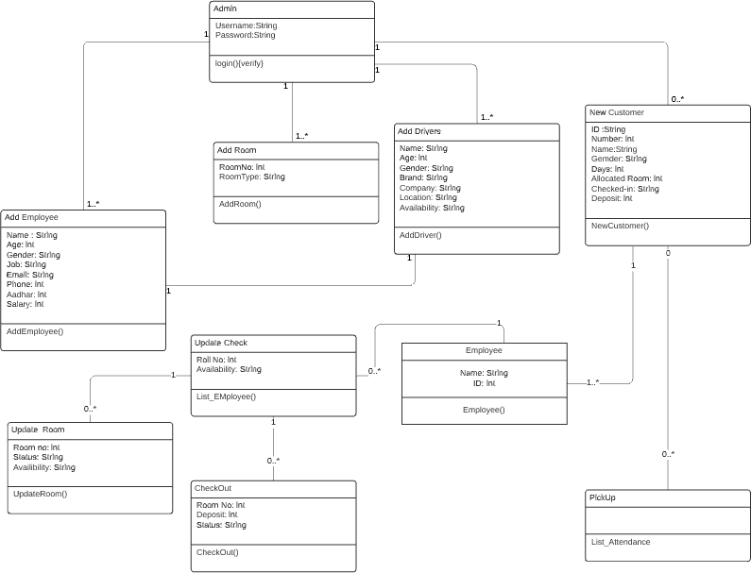

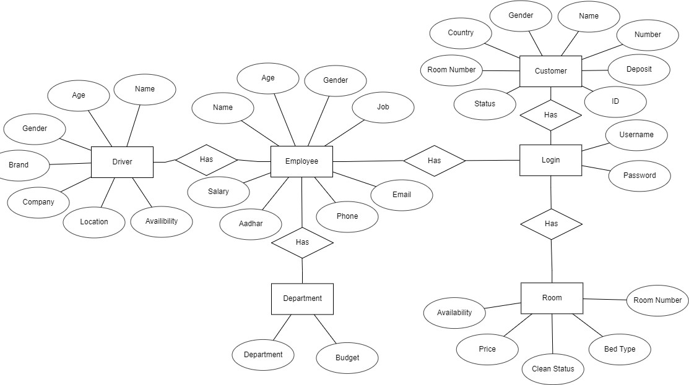

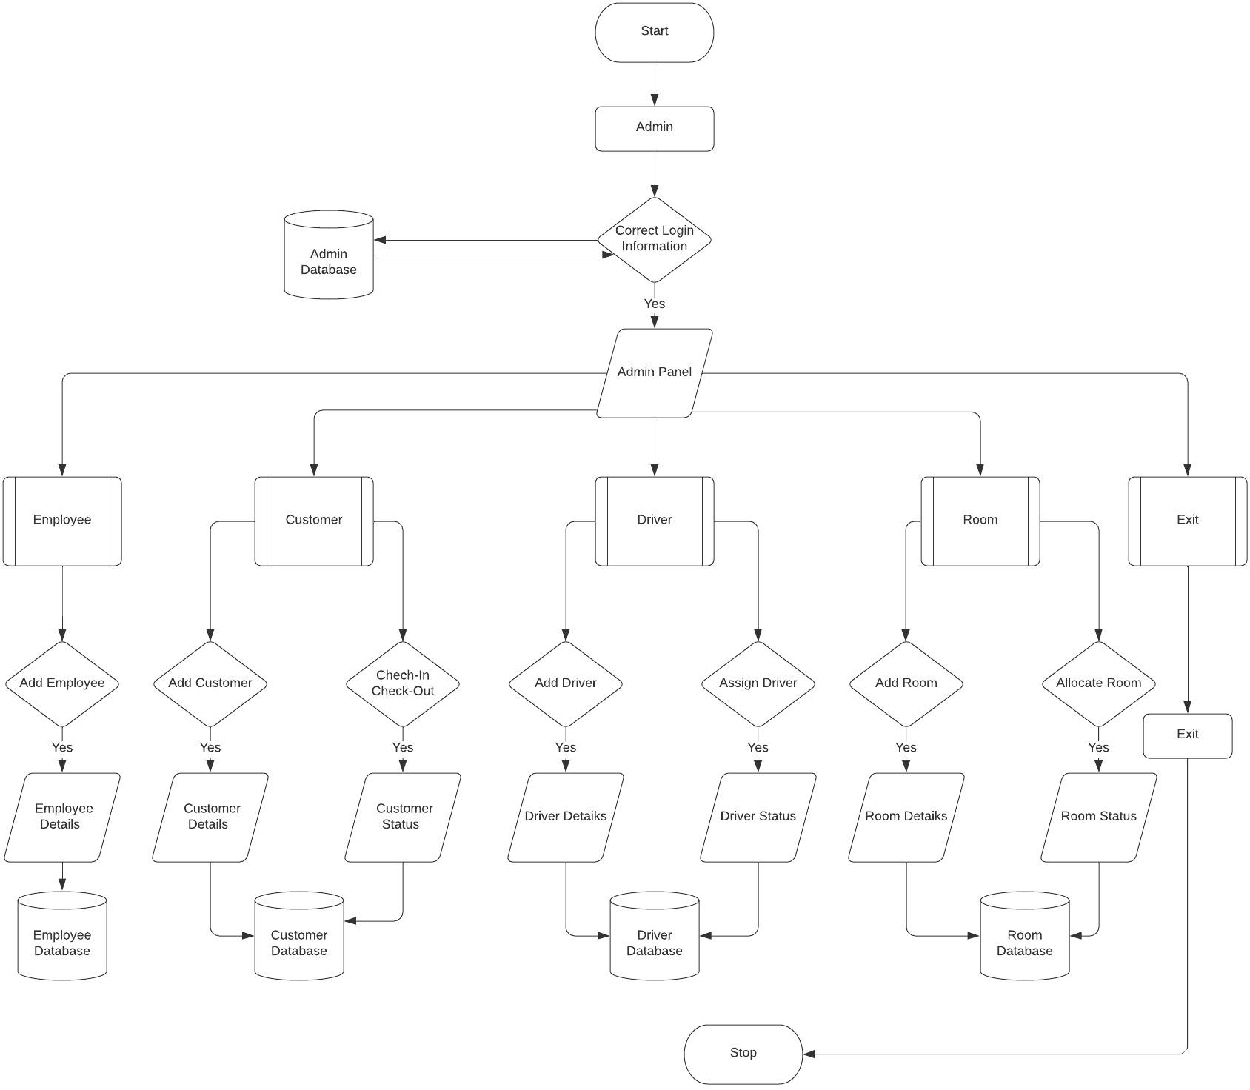

**GIOBAL USE CASE DIAGRAM**

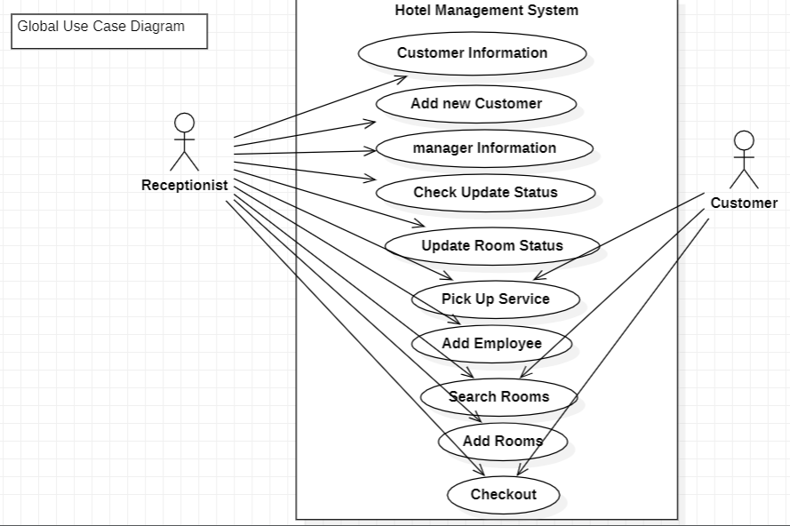

**ACTIVITY DIAGRAMS**

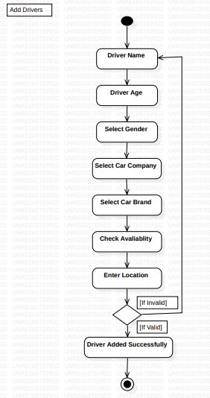

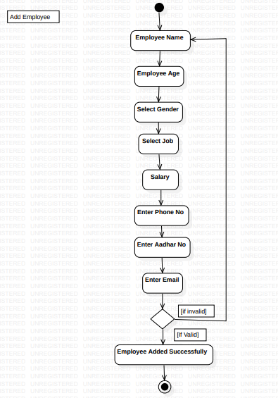

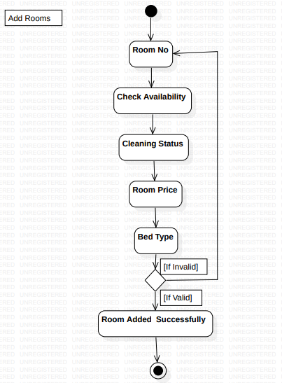

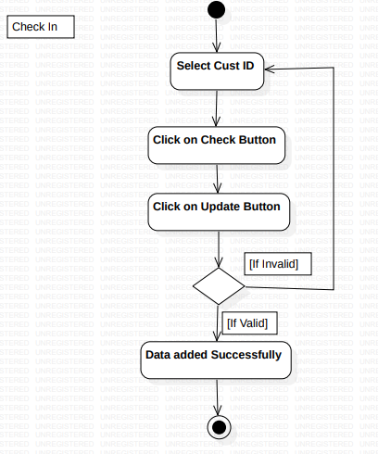

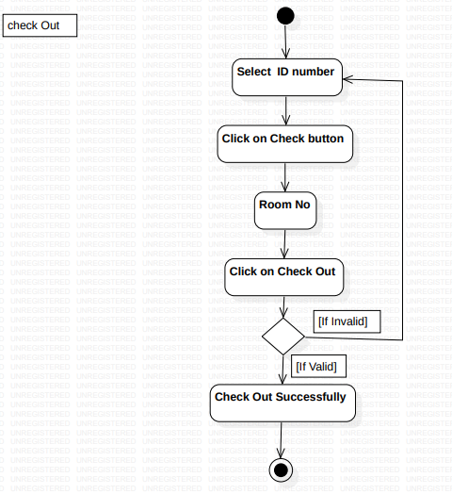

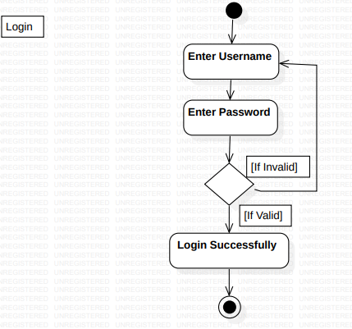

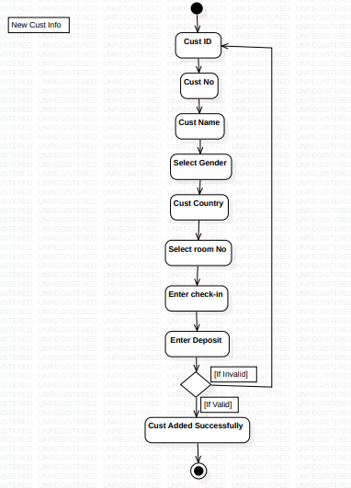

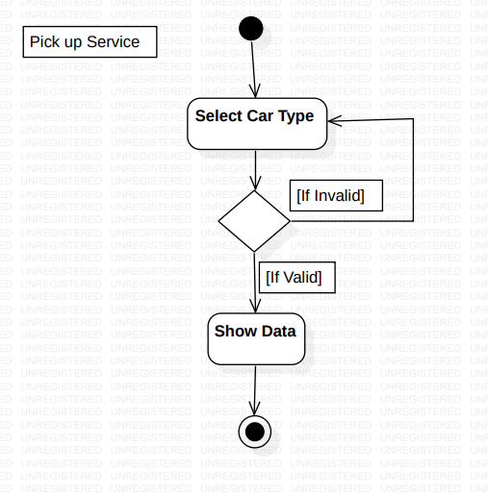

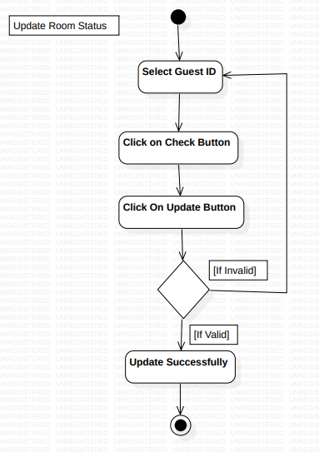

**SEQUENCE DIAGRAMS**

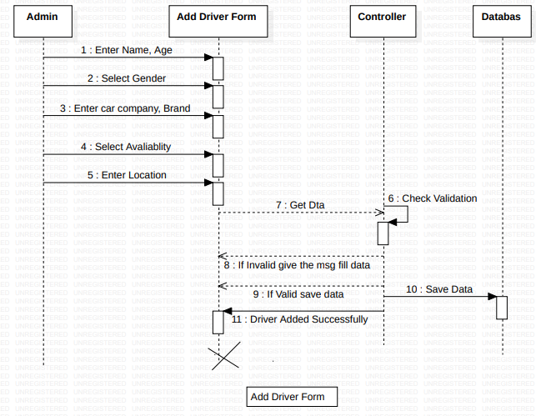

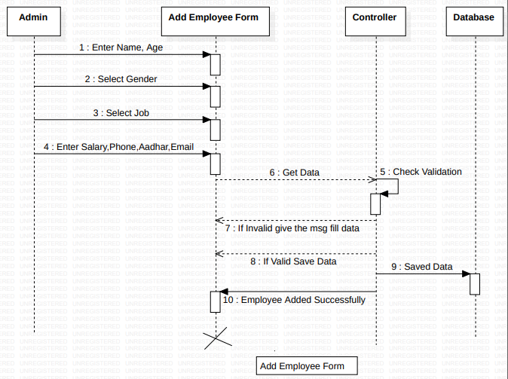

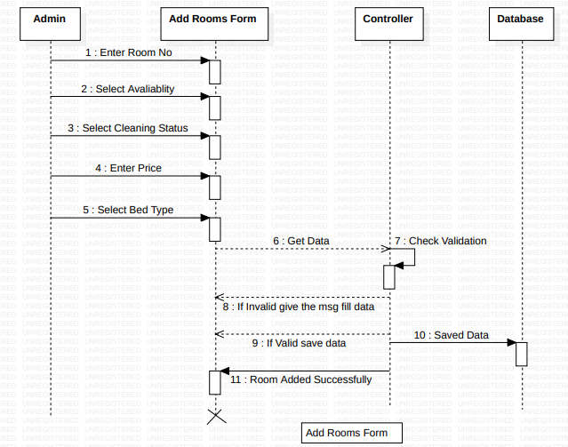

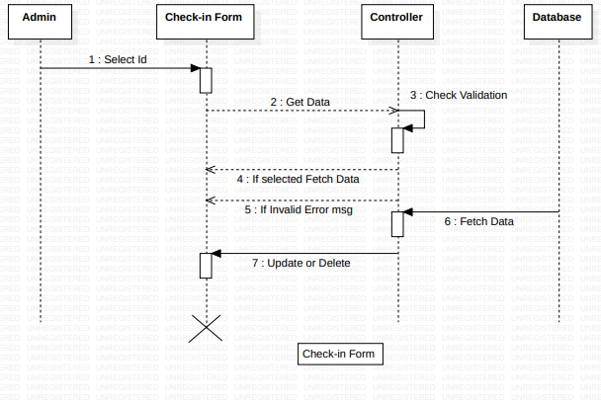

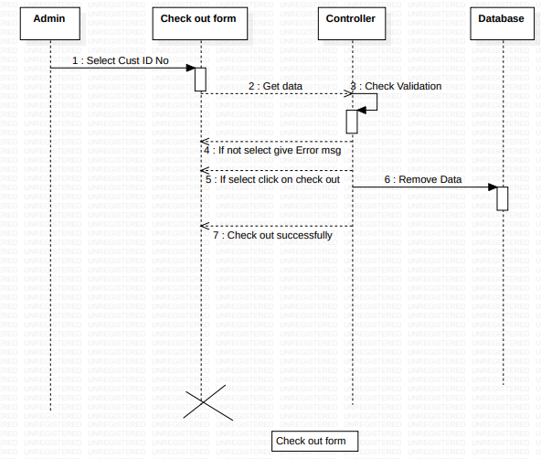

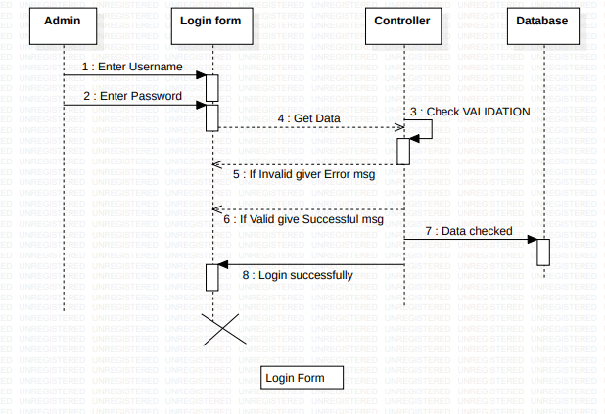

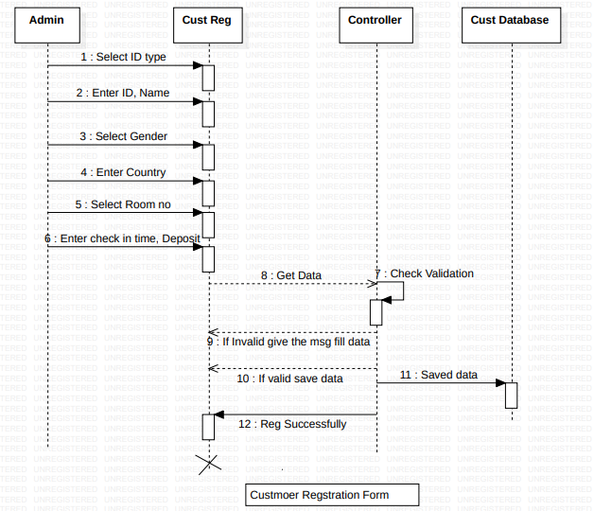

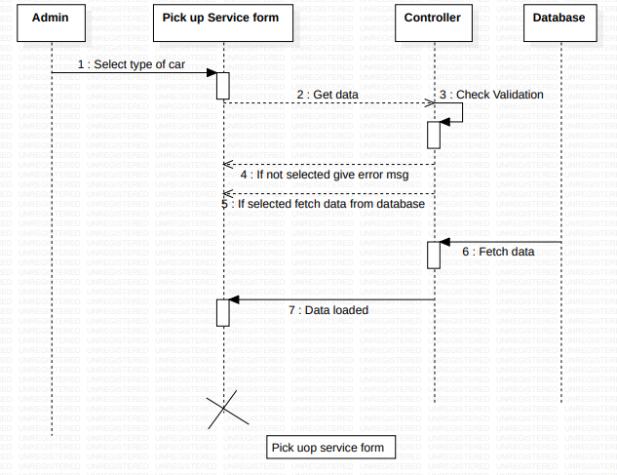

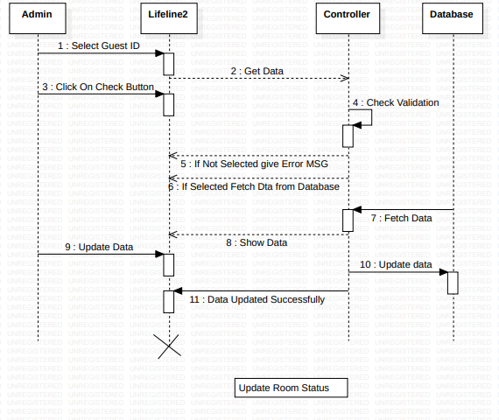

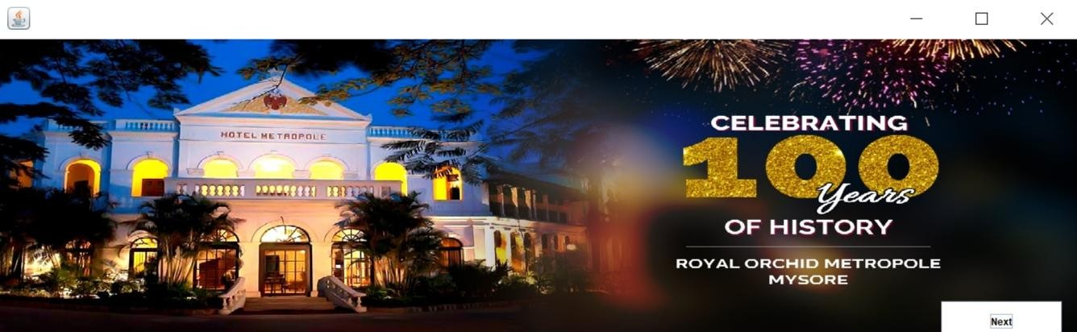**SCREENSHOTS**

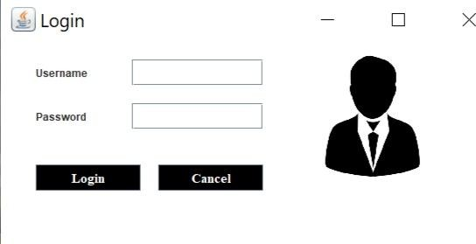

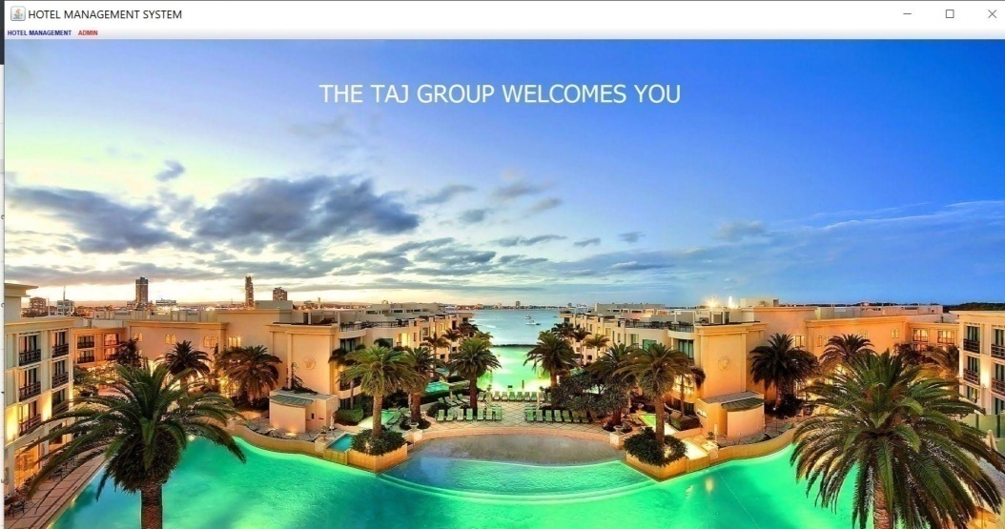

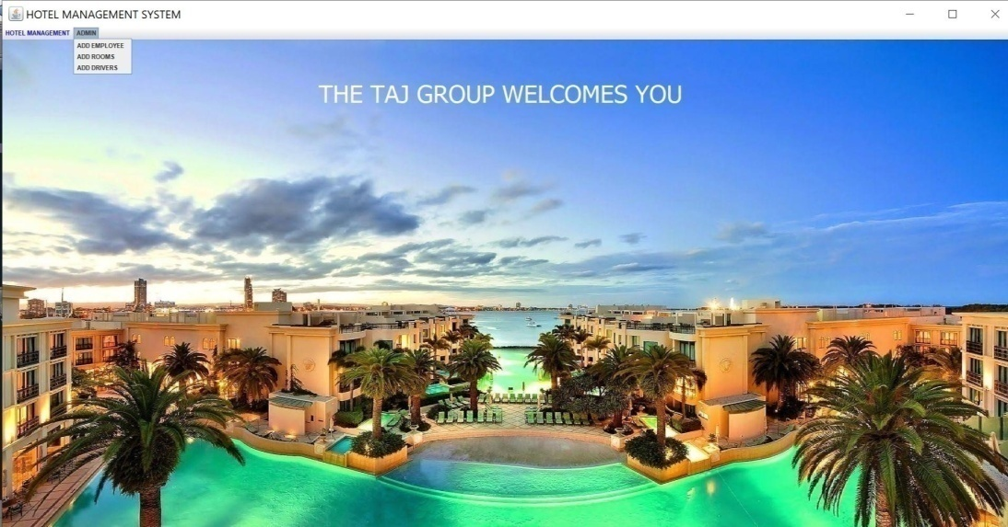

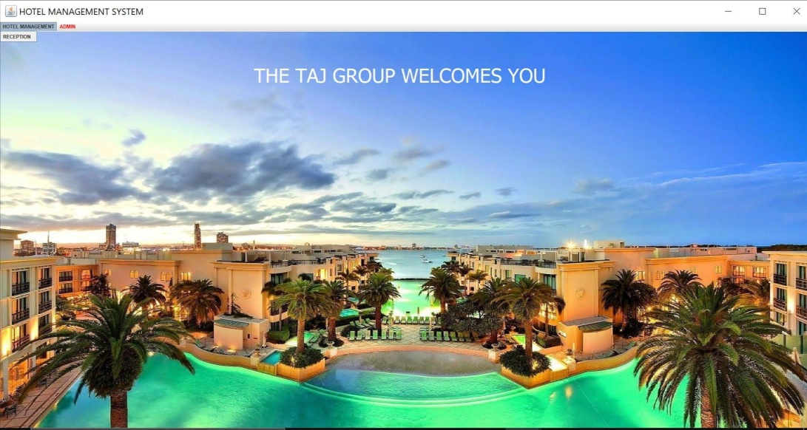

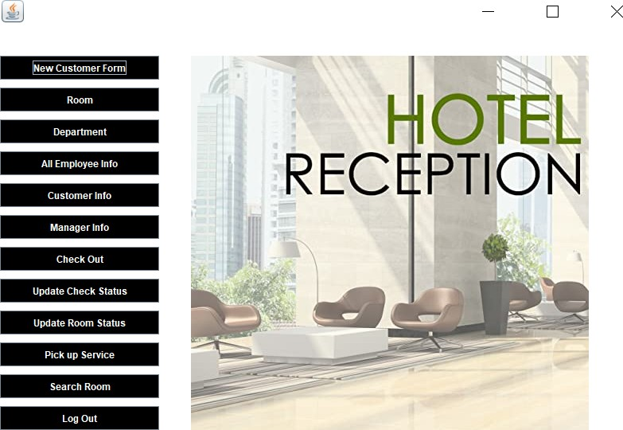

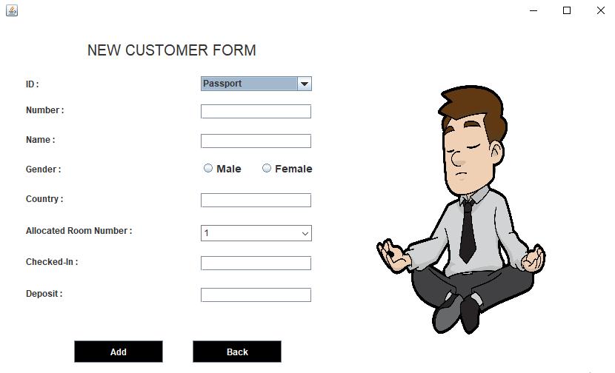

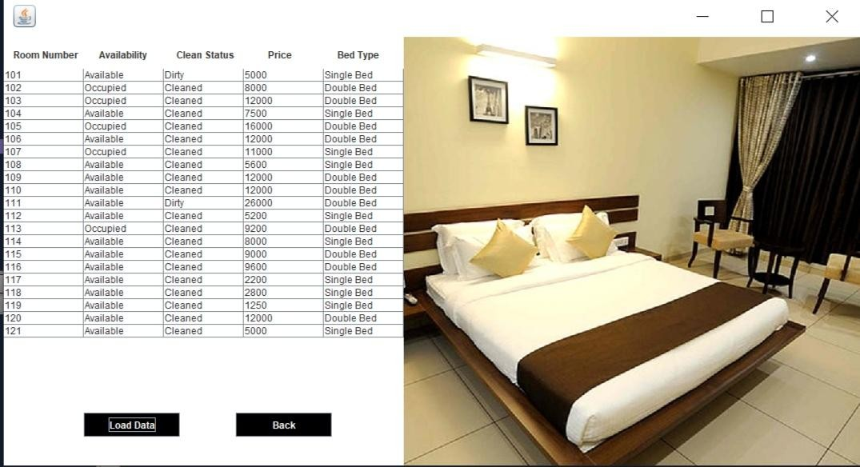

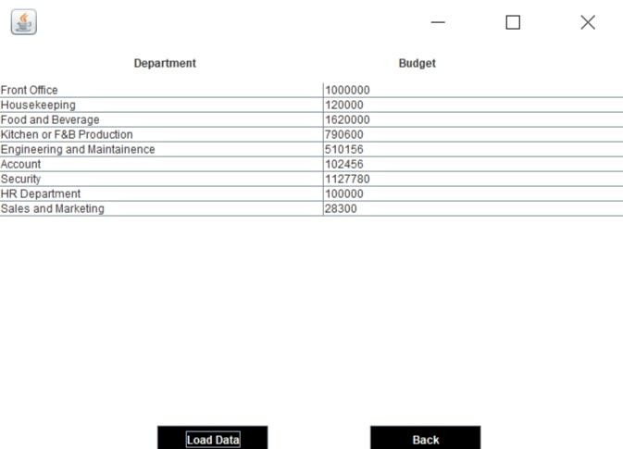

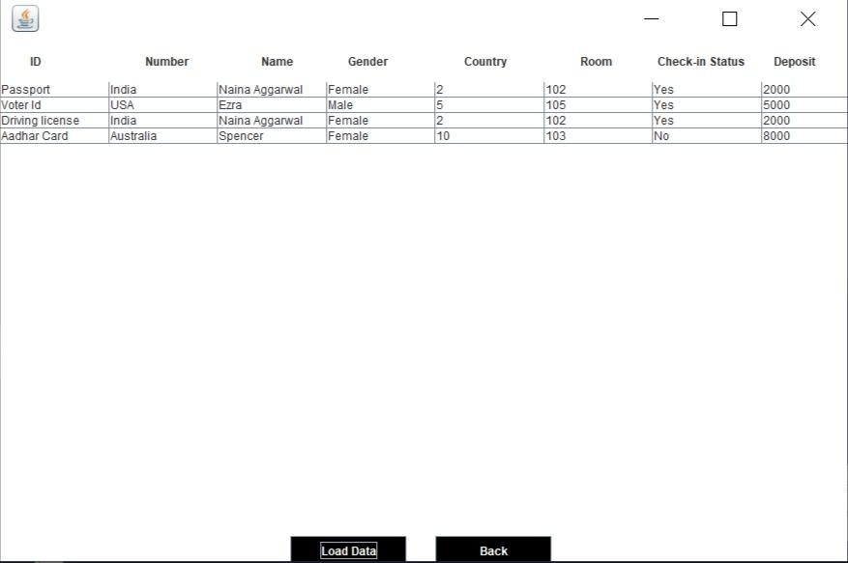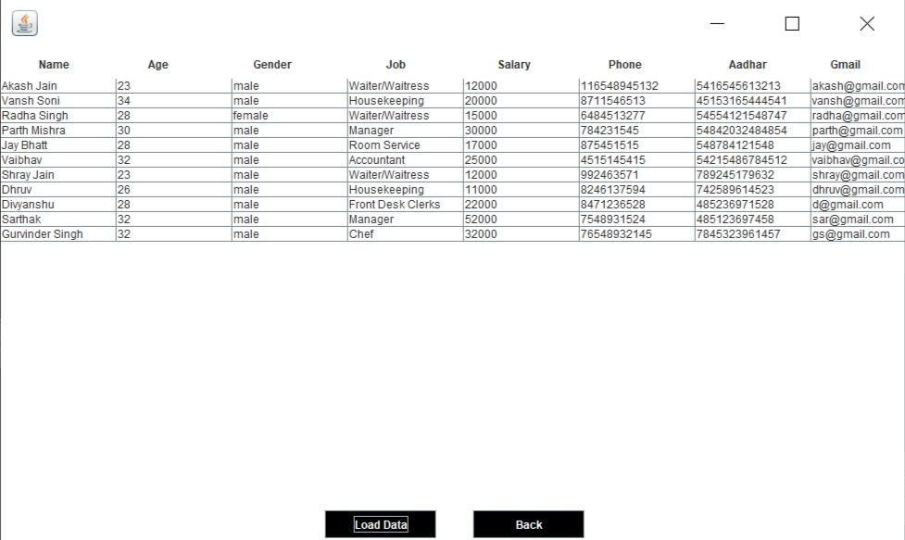

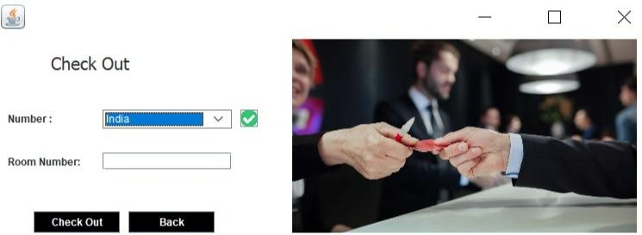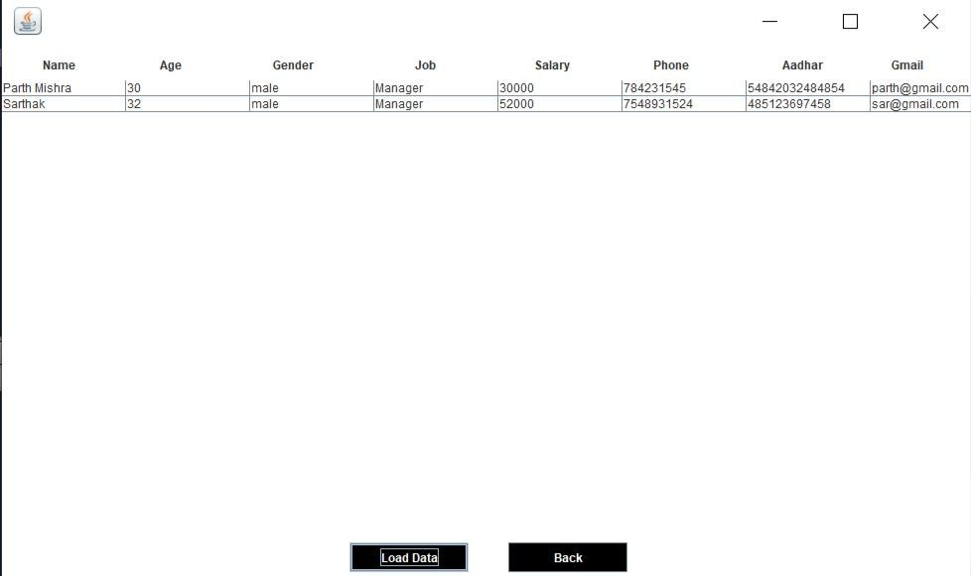

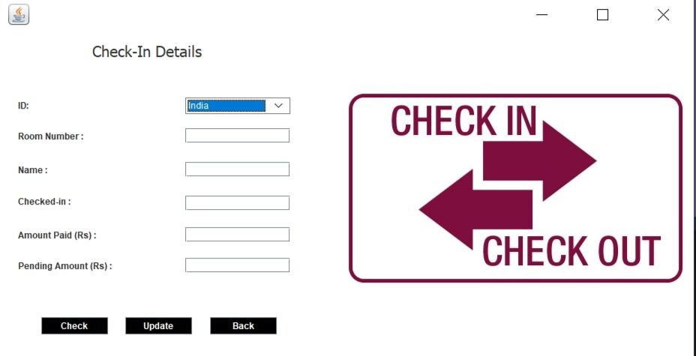

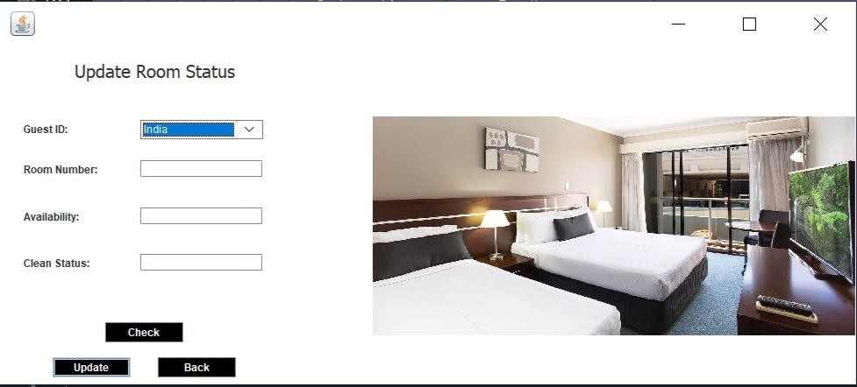

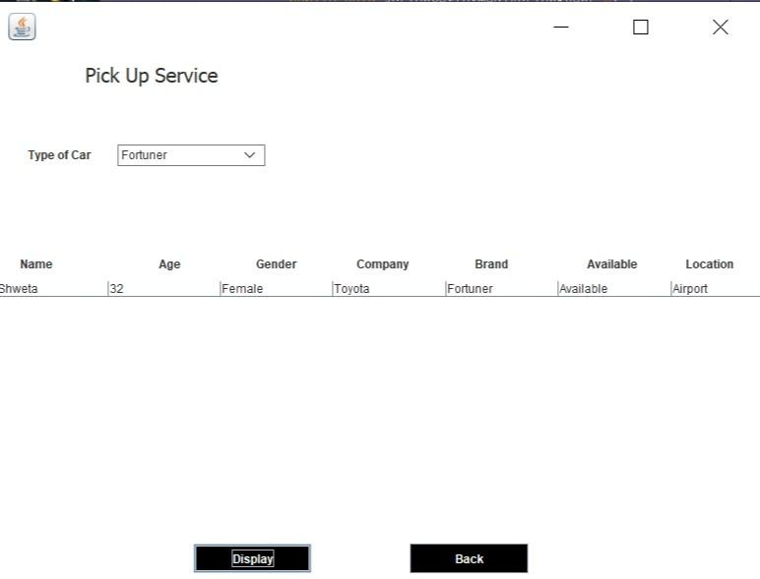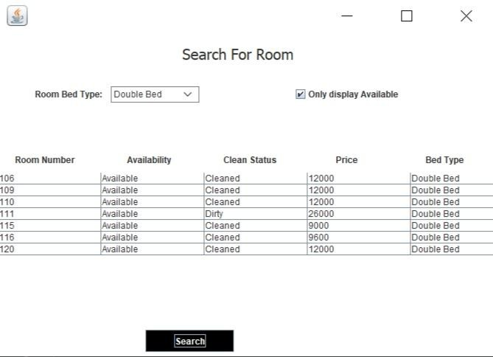

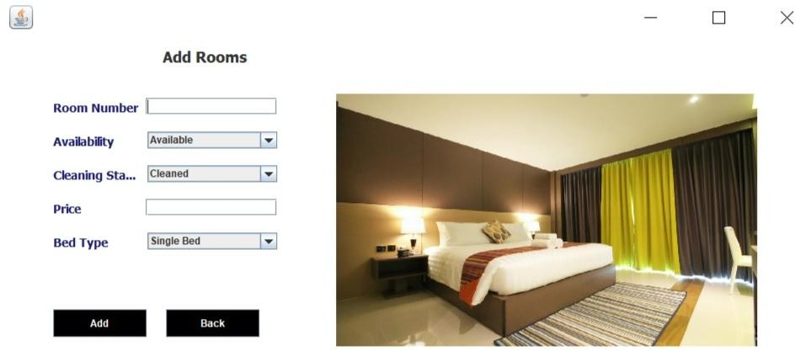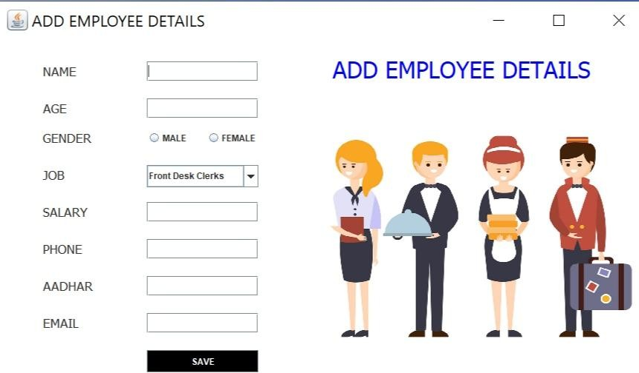

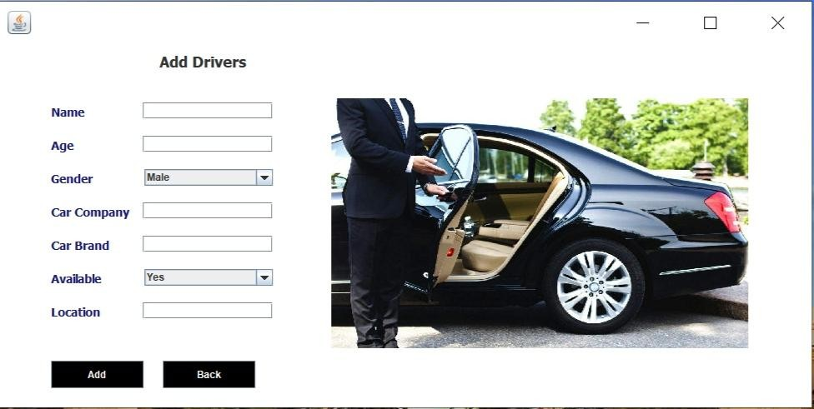

**7. Database Tables**

1. **Customer**

|  |  |  |
| --- | --- | --- |
| **Field** | **Datatype** | **Constraint** |
| Id | Varchar(30) | NN |
| number | Numeric(30) | PK |
| name | Varchar(30) | NN |
| gender | Varchar(30) | NN |
| country | Varchar(30) | NN |
| Room number | Numeric(30) | NN |
| Status | Varchar(30) | NN |
| Deposit | Numeric(30) | NN |

1. **Room**

|  |  |  |
| --- | --- | --- |
| **Field** | **Datatype** | **Constraint** |
| Room_number | Numeric(30) | PK |
| availability | Varchar(30) | NN |
| Clean status | Varchar(30) | NN |
| Price | Number(30) | NN |
| BedType | Varchar(30) | NN |

1. **Employee**

|  |  |  |
| --- | --- | --- |
| **Field** | **DataType** | **Constraint** |
| Name | Varchar(30) | NN |
| Age | Numeric(30) | NN |
| Gender | Varchar(30) | NN |
| Job | Varchar(30) | NN |
| Salary | Number(30) | NN |
| Phone | Number(30) | NN |
| Adhar | Number(30) | PK |
| Email | Varchar(30) | NN |

1. **Driver**

|  |  |  |
| --- | --- | --- |
| **Field** | **DataType** | **Constraint** |
| Name | Varchar(30) | NN |
| Age | Numeric(30) | NN |
| Gender | Varchar(30) | NN |
| Company | Varchar(30) | NN |
| Brand | Varchar(30) | NN |
| Available | Varchar(30) | NN |
| Location | Varchar(30) | NN |

1. **Login**

|  |  |  |
| --- | --- | --- |
| **Field** | **DataType** | **Constraint** |
| Username | Varchar(30) | PK |
| Password | Varchar(30) | NN |

1. **Department**

|  |  |  |
| --- | --- | --- |
| **Field** | **DataType** | **Constraint** |
| Department | Varchar(30) | PK |
| Budget | Numeric(30) | NN |

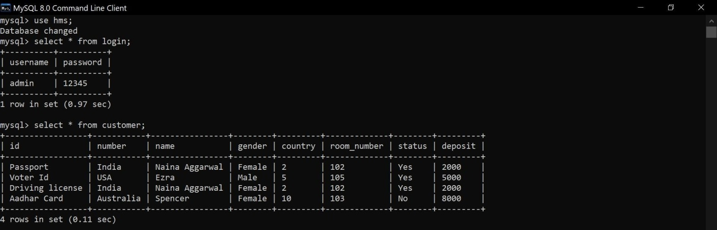

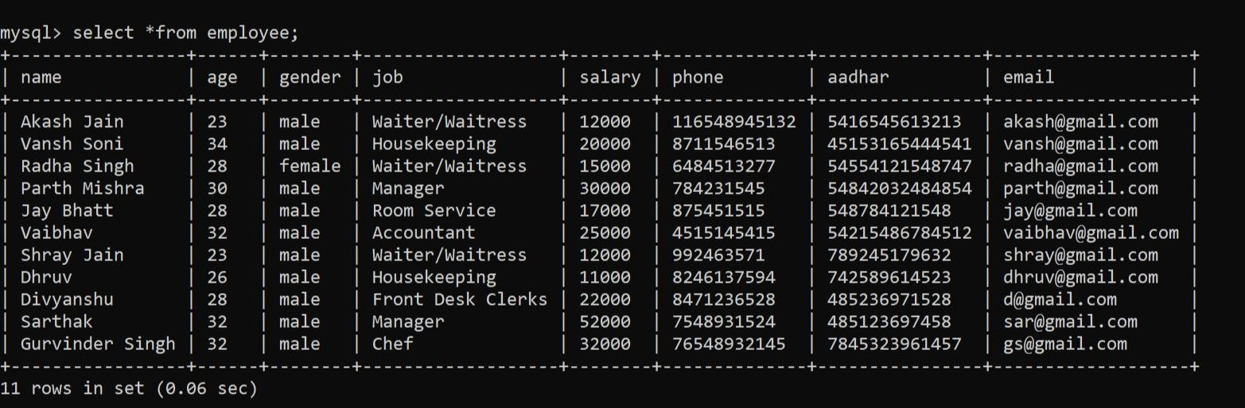

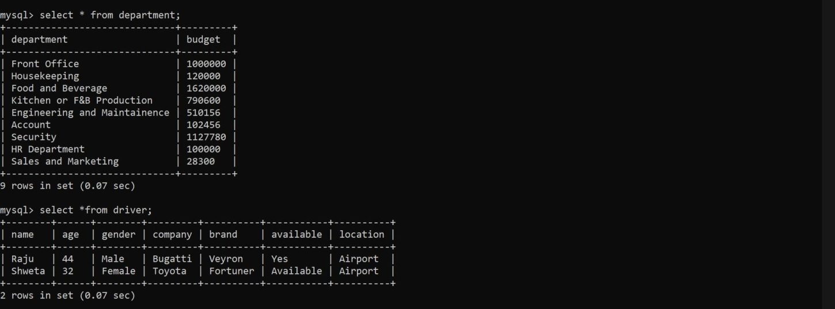

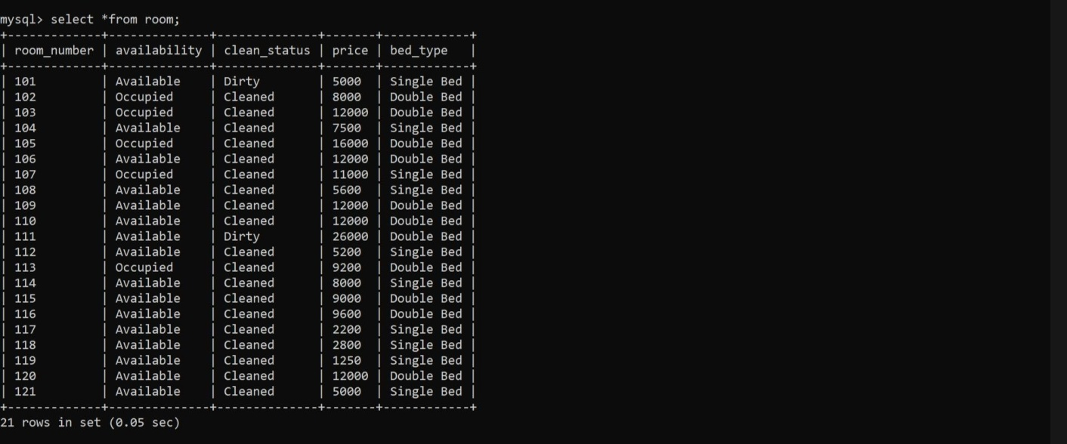

**TESTING**

**Unit Testing**

Unit testing is a testing technique in which modules are tested individually. Small individual units of source code are tested to determine whether it is ﬁt to use or not. Diﬀerent modules of games are put to test while the modules are being developed. Here modules refer to individual levels, players, scenes.

**Integration Testing**

Integration testing is the technique in which individual components or modules are grouped together and tested. It occur software testing. The input for the integrated testing, are the modules that have already been unit tested.

**System Testing**

System testing is conducted on the entire system as a whole to check whether the system meet sits requirements or not. ‘Valar Morghulis’ was installed on diﬀerent systems and any errors or bugs that occurred were ﬁxed.

**Acceptance Testing**

User Acceptance is deﬁned as a type of testing performed by the Client to certify the system with respect to the requirements that was agreed upon. This testing happen since the ﬁnal phase of testing before moving the software application to the Market or Production environment.

# **9. FUTURE SCOPE**

The world is changing rapidly and so is the meaning of the Hotel Management System. Today hotel management is not only confirmed to hotels but has gone deep into tourism, catering, clubs, etc making it a very paying and an exciting career option.

With the rapid growth of the hotel industry pushed forward by foreign and domestic tourism and business travels, the demand for well trained and quality personnel too has gone up high. India is one of the preferred tourist and travel destinations. Approx 4.4 million tourists visit our country every year. The growth of 20% has been recorded in the tourist and hospitality industry over a few years and more growth is expected in coming years. At present, there are about 200 millions of jobs available in the industry, out of which 20% of the job opportunities are in India.

The Hotel Management System has a lot of enhancement options. In future more features may be added category-wise. It may try to analyze the user behaviour and preferences and accordingly suggest. All concepts can be applied to make the Hotel Management System more efficient.

**CONCLUSION**

The entire project has been developed and deployed as per the requirements started by the user,

It is found to be bug free as per the testing standards that are implemented. Any specification

untraced errors will be concentrated in the coming versions, which are planned to be developed

in near future.

The system at present does not take care of the money payment methods, as the consolidated

Constructs need SSL standards and are critically to be initiated in the first face, the application

Of the credit and transactions is applied as a development phase in the coming days. The system

Needs more elaborative technically for its inception and evolution.